Navigation Corrections Example

Navigation corrections from the 1010H1 flight into Hurricane Michael were used to verify the process in Solo II and expected outcomes. Testing in HawkEdit will be evaluated by the ability to replicate these outcomes.

# Aft Facing Scan Case

Start by running the command in the terminal export CFAC_FILES=”N42RF-TS > cfac.aft”. When you first open the program there will be no info in the cfac block which you can check by opening the examine widget and then displaying file metadata:

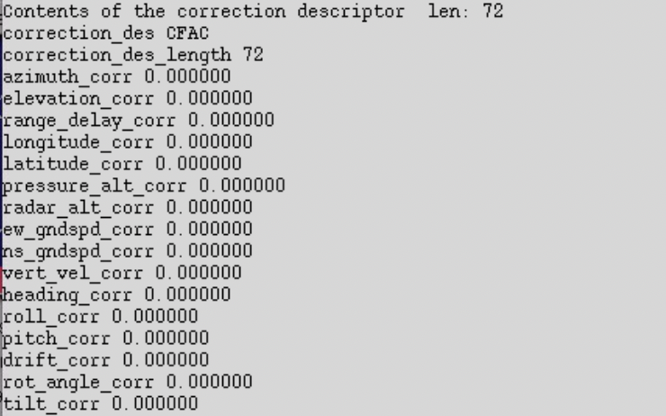

When you open Solo II, the terminal should say it is opening the cfac file as the program starts. Before corrections the data looks like this:

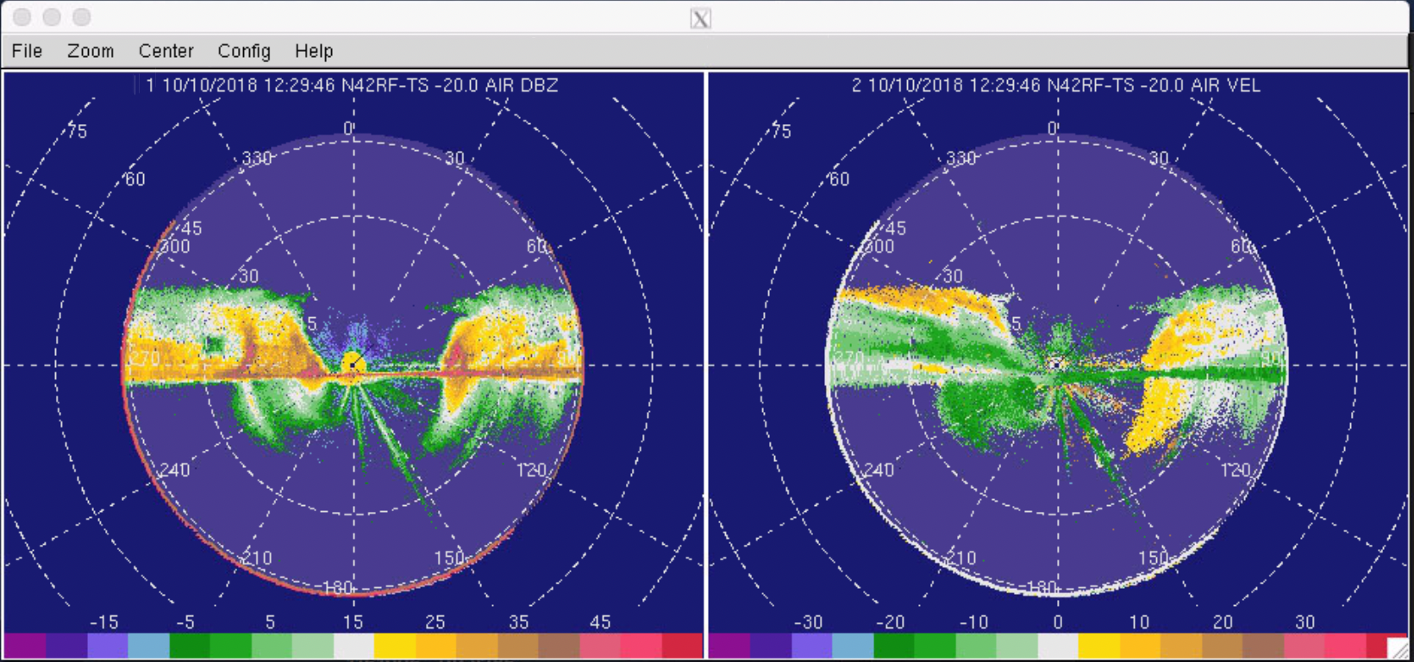

In Solo II, display the file metadata to show that the cfac block has been altered which should happen once you run the command “copy VEL to VG”:

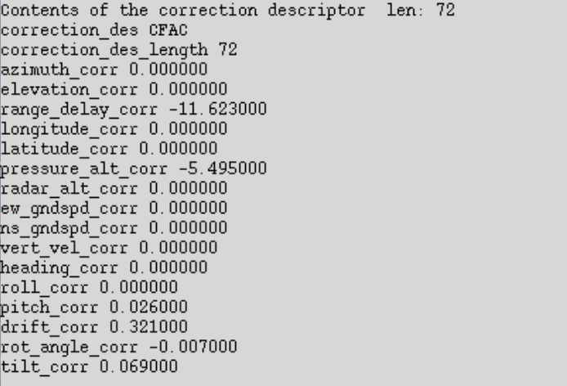

Now run the command block:

Remove-aircraft-motion in VG

Copy VG to VR

Once these commands are run the navigation corrections have been run. The difference will be noticed in the VG and VR fields after the corrections have been applied:

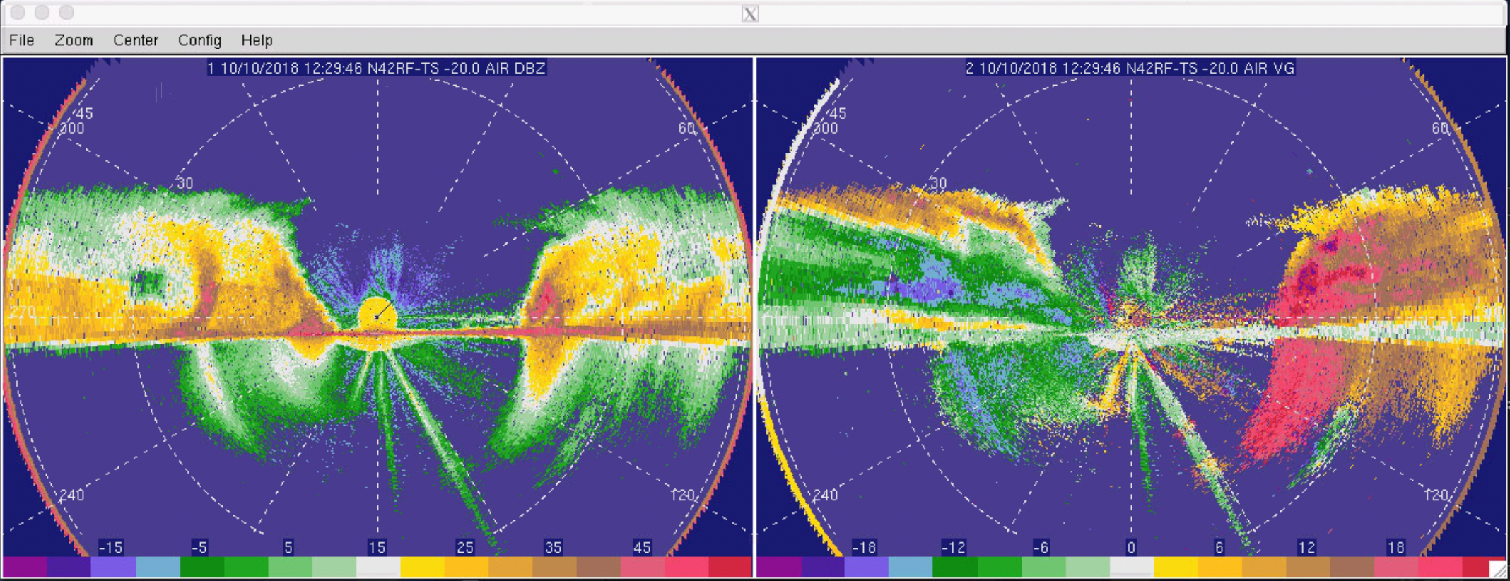

# Fore Facing Scan Case

Everything is the same but the export command changes to: export CFAC_FILES=”N42RF-TM > cfac.fore”.

Before:

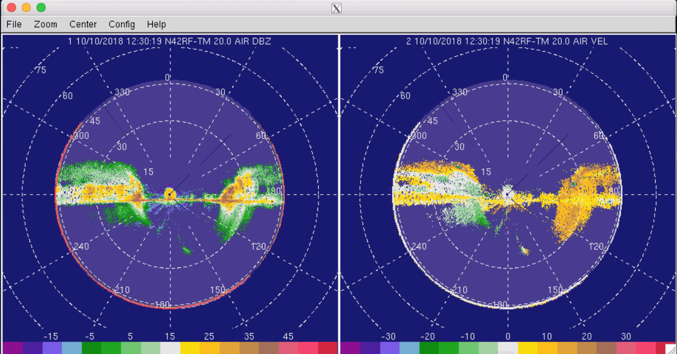

After:

